**Enterprise Resource Planning**

**Training User Manual**

**VERSION 12.0.0**

**Leave Reports**

**Index**

|  |  |
| --- | --- |
| **About** | **Page No.** |
| * **Leave Reports Location** | **03** |
| * Personal Leave Information | **04** |
| * Date wise Leave Information | **06** |
| * Pending Leave Application | **07** |
| * Date wise Personal Leave Information | **08** |
| * Leave Details in Particular Date | **09** |
| * Suffix/Prefix Leave Applicable List | **10** |

**Leave Reports**

**Choose the parameter Short/ Long to show reports Hourly/Day wise**

|  |  |
| --- | --- |
| **Step 1** | Open System **>** Leave Management **> Reports** |
| **Step 2** | Select the Report option to show any Report |
| **Step 3** | Fix the required Parameters and then click on **View Report** Button |

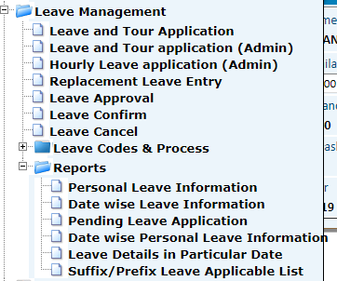

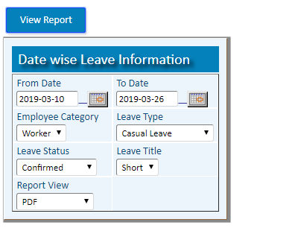

1. **Personal Leave Information**

**(To Show the number Assigned Leave, Used & Available Leave for the Year of any Staff)**

|  |  |
| --- | --- |
| **Step 1** | Open System **>** Leave Management **> Reports** |
| **Step 2** | Select the Report option [**Personal Leave Information**](http://localhost:8080/zab/login?screen=*viewcrystal+pdselfleaveinfo%287%3Bin%2Cst%2Cin%2Cst%2Cst%2Cst%2Cst%3Bzid%2Cstaff%2Cyear%2Crpttype%2Cempcat%2Cadminid%2Cleavetype%3Bxstaff%3DEmployee+ID%2Cxyear%3DYear%2Cxtyperpt%3DReport+Type%2Cxhide%3Dadmin+ID%2Cxhide%3Dadmin+ID%2Cxleavetype%3DLeave+Types%2Cxviewtype%3DReport+View%29&option=Personal+Leave+Information&menuname=pdperrpt) |
| **Step 3** | Choose the parameter **Short/ Long** to show reports **Hourly/Day** wise |
| **Step 4** | Pick the desired Staff ID, Year, Report Type(Summary, Brief, detail), Leave Type and then click on **View Report** Button |

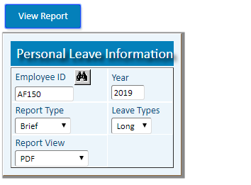

**Summary Report** (Long for day wise)

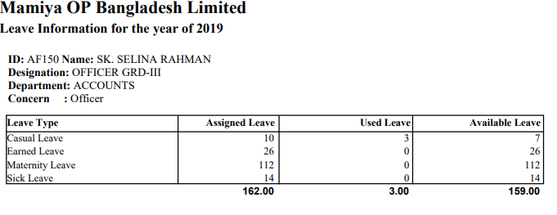

**Summary Report** (Short for hour wise)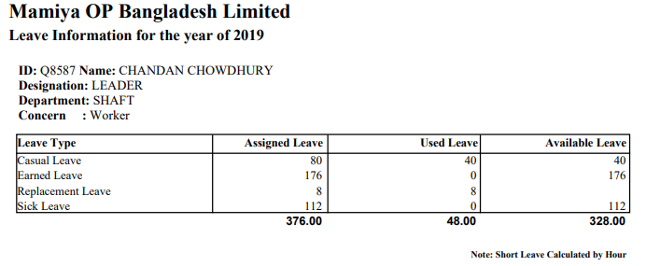

**Brief Report**

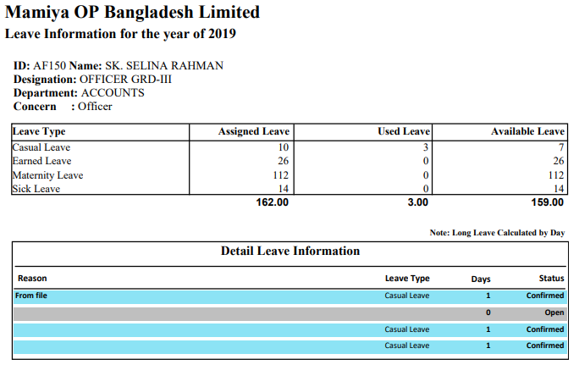

**Detail Report**

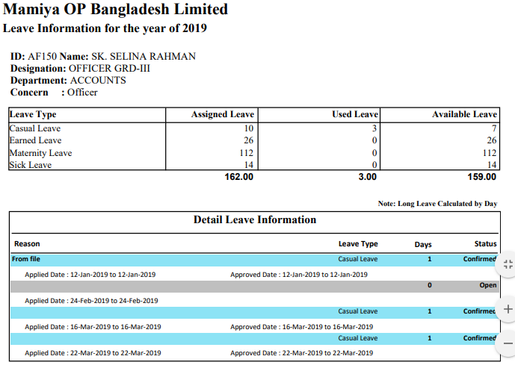

1. **Date wise Leave Information**

**(To Show department wise daily Attendance Info of staffs)**

**(Choose the parameter Short/ Long to show reports Hourly/Day wise)**

|  |  |
| --- | --- |
| **Step 1** | Open System **>** Leave Management **> Reports** |
| **Step 2** | Select the Report option [**Date wise Leave Information**](http://localhost:8080/zab/login?screen=*viewcrystal+pdleaverep%287%3Bin%2Cdt%2Cdt%2Cst%2Cst%2Cst%2Cst%3Bzid%2Cfdate%2Ctdate%2Cempcat%2Cleavetype%2Cstatus%2Cxleavetype%3Bxdate%3DFrom+Date%2Cxdate%3DTo+Date%2Cxempcategory%3DEmployee+Category%2Cxtypeleave%3DLeave+Type%2Cxstatuslvrep%3DLeave+Status%2Cxleavetype%3DLeave+Title%2Cxviewtype%3DReport+View%29&option=Date+wise+Leave+Information&menuname=pdperrpt) |
| **Step 3** | Pick the start Date, End Date, Staff Category, Leave Type, Status and then click on **View Report** Button |



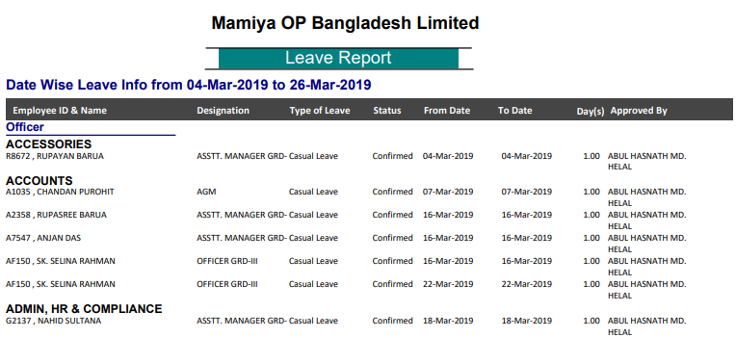

1. **Pending Leave Application**

**(To Show date wise Pending Leave Application status)**

|  |  |
| --- | --- |
| **Step 1** | Open System **>** Leave Management **> Reports** |
| **Step 2** | Select the Report option [**Pending Leave Application**](http://localhost:8080/zab/login?screen=*viewcrystal+pdleaverepsup%286%3Bin%2Cdt%2Cdt%2Cst%2Cst%2Cst%3Bzid%2Cfdate%2Ctdate%2Cempcat%2Csuperior%2Cleavetype%3Bxdate%3DFrom+Date%2Cxdate%3DTo+Date%2Cxempcategory%3DEmployee+Category%2Cxposition%3DSuperior+ID%2Cxleavetype%3DLeave+Type%2Cxviewtype%3DReport+View%29&option=Pending+Leave+Application&menuname=pdperrpt) |
| **Step 3** | Pick the start Date, End Date, Staff Category, Superior ID, Leave Type and then click on **View Report** Button |

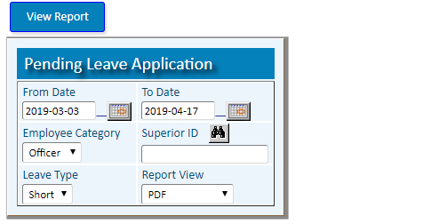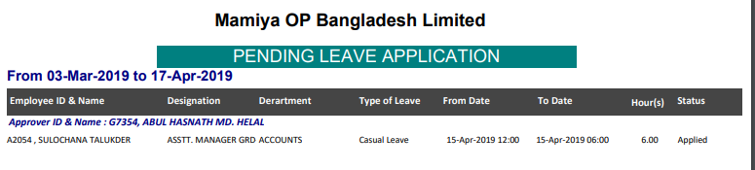

1. **Date wise Personal Leave Information**

**(To Show Date Wise personal Leaves)**

|  |  |
| --- | --- |
| **Step 1** | Open System **>** Leave Management **> Reports** |
| **Step 2** | Select the Report option **Date wise Personal Leave Information** |
| **Step 3** | Pick the start Date, End Date, Staff ID, Leave Status and then click on **View Report** Button |

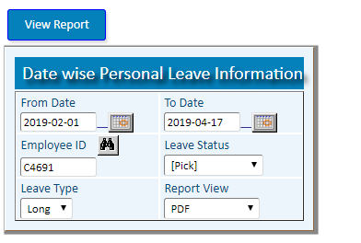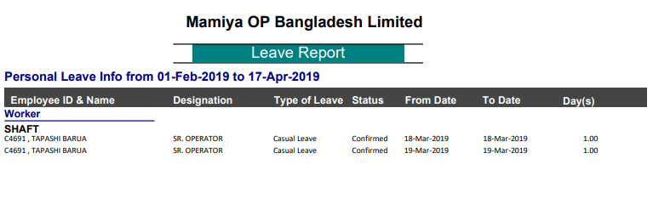

1. **Leave Details in Particular Date**

**(To Show the Leave Detail of all Staffs on any Date)**

|  |  |
| --- | --- |
| **Step 1** | Open System **>** Leave Management **> Reports** |
| **Step 2** | Select the Report option [**Leave Details in Particular Date**](http://localhost:8080/zab/login?screen=*viewcrystal+pdleavedetail%283%3Bin%2Cin%2Cdt%3Bzid%2Cyear%2Cdate%3Bxyear%3DYear%2Cxdate%3DDate%2Cxviewtype%3DReport+View%29&option=Leave+Details+in+Particular+Date&menuname=pdperrpt) |
| **Step 3** | Pick the Year, desired Date and then click on **View Report** Button |

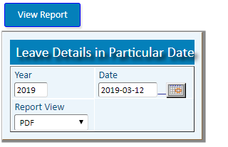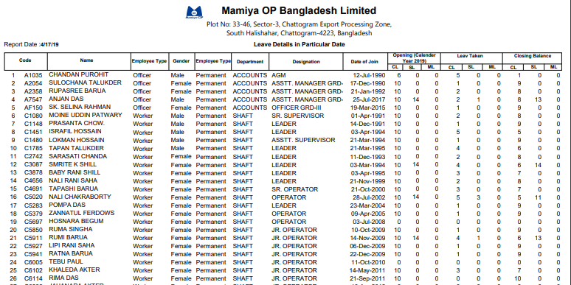

1. **Suffix/Prefix Leave Applicable List**

**(To Show the all Holiday & leave for any Staff)**

|  |  |
| --- | --- |
| **Step 1** | Open System **>** Leave Management **> Reports** |
| **Step 2** | Select the Report option [**Suffix/Prefix Leave Applicable List**](http://localhost:8080/zab/login?screen=*viewcrystal+pdsufprefleaveapplist%284%3Bin%2Cst%2Cst%2Cst%3B%40zid%2C%40pfdate%2C%40ptdate%2C%40pstaff%3Bxdate%3DFrom+Date%2Cxdate%3DTo+Date%2Cxstaff%3D+Employee+ID%2Cxviewtype%3DReport+View%29&option=Suffix%2FPrefix+Leave+Applicable+List&menuname=pdperrpt) |
| **Step 3** | Pick the start Date, End Date, Staff ID and then click on **View Report** Button |

